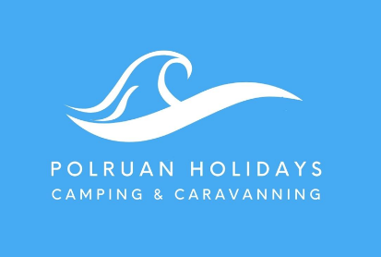 2024 Camping Tariff

 | Low Season | Mid Season | High Season
Prices per night | 29th March 17th May | 18th May – 12th July  September (Adults only) | 13th July – 31st August
Electric pitch | £11 | £13 | £15
Non electric pitch | £8 | £10 | £12
Adult (16+) | £9 | £11 | £13
Child (2-15years) | £6 | £6 | £7
Infants (up to 2 years) | Free | Free | Free
Dog (Max 2 per pitch) | £2 | £2 | £2
Back Packer (1 Person) | £12 | £15 | £18
BP 2 people same pitch no car/no electric | £20 | £25 | £30
Additional car, boat/trailer (subject to availability) | £5 | £5 | £5

Bookings based on a minimum 2 night stay, except for back packers who can book for 1 night only and do not have a car or electric on their pitch
Maximum 4 persons per pitch, to accommodate either one tent and car, one motorhome, one touring caravan/car or one campervan
All Touring caravans have a hard-standing pitch on the top field, with electric hook-up.
Check in from12pm, Check out by 10am

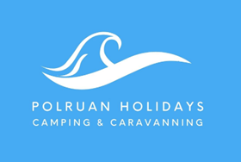 2024 Caravan Tariff
ALL CARAVANS ACCOMMODATE A MAXIMUM OF 4 PERSONS, 7 NIGHT DURATION
W/C SATURDAY | THE HAWK 8 | THE FALCON 9
30th MARCH | 345 | 345
6TH APRIL | 365 | 365
13th APRIL | 385 | 385
20TH APRIL | 385 | 385
27th APRIL | 385 | 385
4th MAY | 430 | 430
11th MAY | 430 | 430
18th MAY | 440 | 440
25th MAY | 500 | 500
1ST JUNE | 485 | 485
8th JUNE | 500 | 500
15th JUNE | 525 | 525
22ND JUNE | 540 | 540
29TH JUNE | 575 | 575
6th JULY | 595 | 595
13th JULY | 760 | 760
20TH JULY | 830 | 830
27th JULY | 830 | 830
3RD AUG | 830 | 830
10th AUG | 830 | 830
17th AUG | 830 | 830
24th AUG | 830 | 830
31ST AUG | 550 | 550
7th SEPT | 485 | 485
14th SEPT | 440 | 440
21ST SEPT | 420 | 420
28TH SEPT | 400 | 400

Don’t forget to bring your own bed linen as this is not included in your caravan
A £100 non-refundable deposit is required to secure your accommodation, with remaining balance to be paid 14 days before your holiday start date. Once paid all monies are non-refundable therefore, we recommend that you purchase suitable insurance to cover any eventualities.
Couples Only high season Offer

Couples of only 2 adults receive a £130 discount between 20th July – 31ST August

Linen hire £35 Double, £25 per single

